Provider | Event | When | Where | More Information
Hans Price Academy | 1-1 Career Guidance Meetings | September - December | Careers Office | All year 11 students will have a careers guidance meeting with Ms Fielding.  Students will be collected from lessons.  jackie.fielding@clf.uk  (01934) 630836 ext:1340
Weston College | ‘What Next?'  Careers Showcase for School Leavers | Wednesday 27th September 2023  5pm – 7pm | The Winter Gardens Ballroom  BS23 1AJ | Discover career opportunities from local and national employers to help discover "What's Next" for you! Book Tickets:  Weston College 'What Next'
National Apprenticeship Roadshow | Year 11 trip to the National Apprenticeship Roadshow | Wednesday 27th September  Leaving school at 11am returning at 3pm | Ashton Gate Stadium Ashton Rd, Bristol BS3 2EJ | Letter will be sent home to parents  National Apprenticeship Roadshow
Weston College | Healthcare Academy | 27 September –  22 November  3pm – 5pm | Health and Active Living Skills Centre  BS23 4QU | Expand your skills and knowledge of healthcare in our FREE Year 11 Healthcare Academy  To register:  Weston College Healthcare Academy
South Gloucestershire & Stroud College (SGSC) | Open Evening  A Levels Only | Thursday 28th September  5.30pm - 8pm | Filton Campus | SGSC Events
Winterstoke Hundred Academy Sixth Form | Open Evening | Wednesday 4th October  4pm-7pm | Beaufighter Rd,  BS24 8EE | Winterstoke Hundred Academy Sixth Form
Boomsatsuma  Games/VFX/VR  Photography & Creative Digital Media | Open Evening | Monday 2nd October  Tuesday 3rd October | Leadworks One Millennium Square, Bristol BS1 5DB | Boomatsuma Events
Boomsatsuma  Sports Media Production | Open Evening | Wednesday 4th October | Ashton Gate Stadium Ashton Rd, Bristol BS3 2EJ | Boomatsuma Events
Boomsatsuma  Film, TV & Acting | Open Evening | Thursday 5th October | Bottleyard Studios, Hengrove, BS14 0BH | Boomatsuma Events
South Gloucestershire & Stroud College (SGSC) | Open Day  All Campuses | Saturday 7th October 10am-1pm | All Campuses | Reserve a place:  SGSC Open Day
Bridgwater College  Bridgwater Campus | Open Evening | Tuesday 10 October  6pm - 8pm | Bath Road Bridgwater  TA6 4PZ | To register:  Bridgwater and Taunton College Events
Bridgwater College  Tanton Campus | Open Evening | Wednesday 11th October  6pm - 8pm | Taunton Campus  Wellington Road  Taunton  TA1 5AX | To register:  Bridgwater and Taunton College Events
Churchill Sixth Form Open Evening | Open Evening | Thursday 12th October  5.45pm | Churchill Green, Churchill  North Somerset, BS25 5QN | To book:  Churchill Sixth Form Open Evening
Weston College | Open Evening  for School Leavers and Adults | Wednesday 11th October  5pm-7pm | All Campuses | Weston College Events
Bristol Robins Foundation | Open Evening | TBC | Ashton Gate Stadium | Bristol City Robins Foundation
City of Bristol College | Open Evening | TBC | All Campuses | City of Bristol College

Post-16 assemblies which be held at Hans Price Academy for all year 11 students
25th September | Winterstoke Hundred Academy Sixt Form
2nd October | Bridgwater College
9th October | Churchill Sixth Form
30th October | Weston College
13th November | ASK Apprenticeships
20th November | The Army
27th November | Bristol Robins Foundation
4th December | Boomsatsuma
29th January 2024 | City of Bristol College

Career Platforms
All Hans Price Students have an account with Unifrog to explore future careers and post-16 options
https://www.unifrog.org/
Career Pilot is free to use and explore careers and post-16 options
https://www.careerpilot.org.uk/

Post-16 Providers

https://winterstokehundredacademy.clf.uk/
https://www.weston.ac.uk/
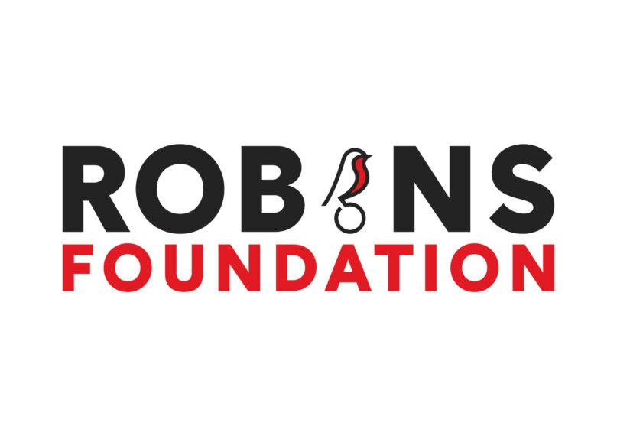
https://www.bcfc.co.uk/robins-foundation/post-16-courses/
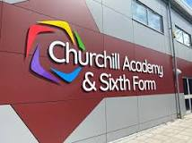
https://www.churchill-academy.org/
https://www.btc.ac.uk/
https://www.sgscol.ac.uk/
https://www.cityofbristol.ac.uk/
https://www.boomsatsuma.com/

Any questions or to make an appointment to see me please email, phone or visit the Academy

Jackie Fielding
Careers Advisor/WEX Co-ordinator
Email: jackie.fielding@clf.uk or call (01934) 630836 ext:1340

